**RESULT AND DISCUSSION**

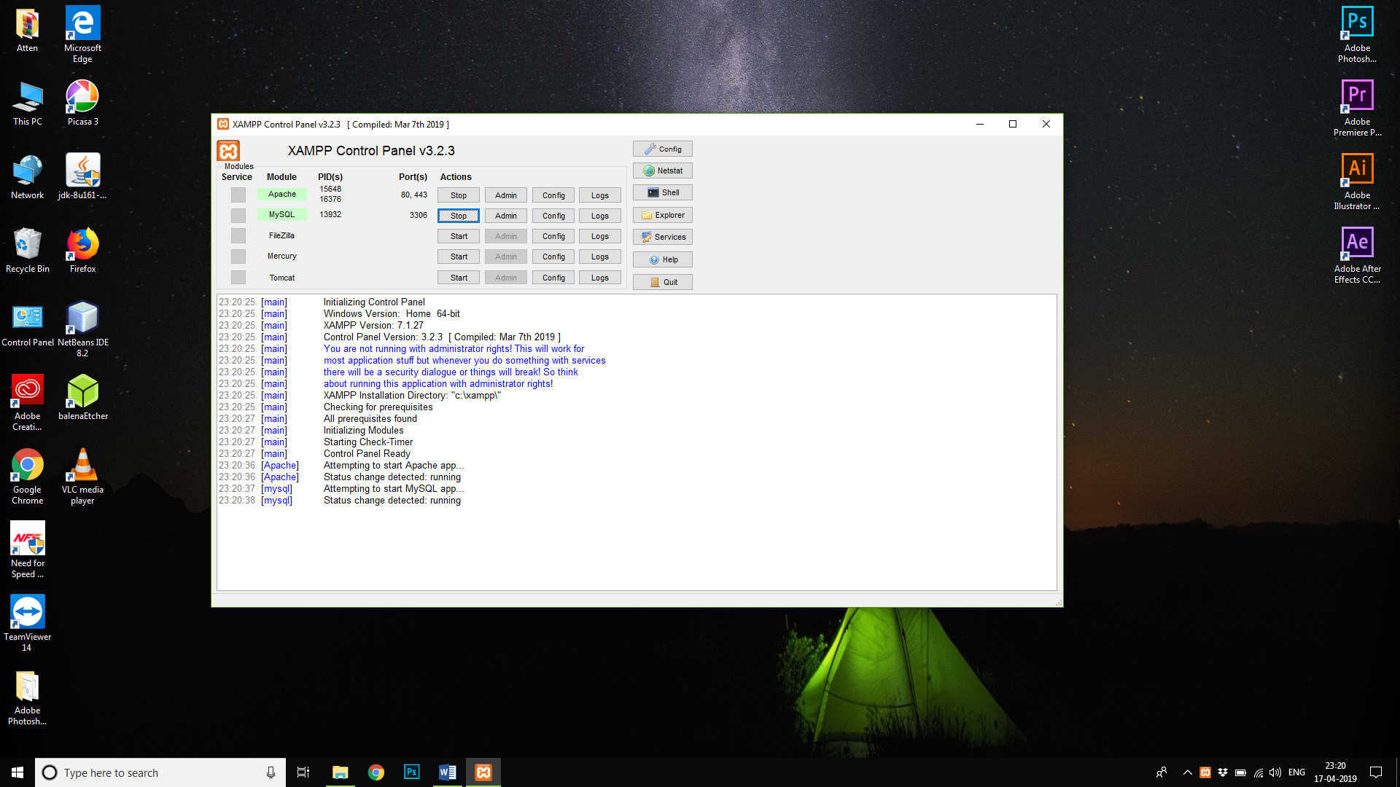

Fig No 1 : Enable Apache and SQL From the Xampp Control Panel to make Your computer a local host for the software

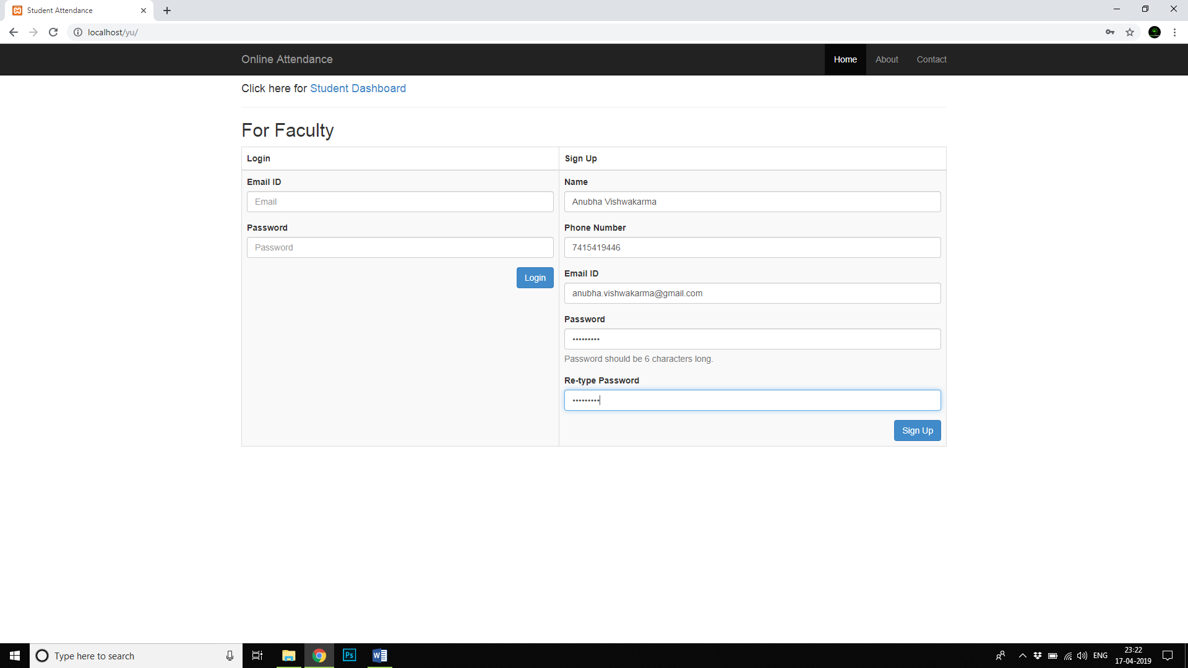

Fig No 2 : Type localhost/yu in the browser.The sign up page for faculty will appear.

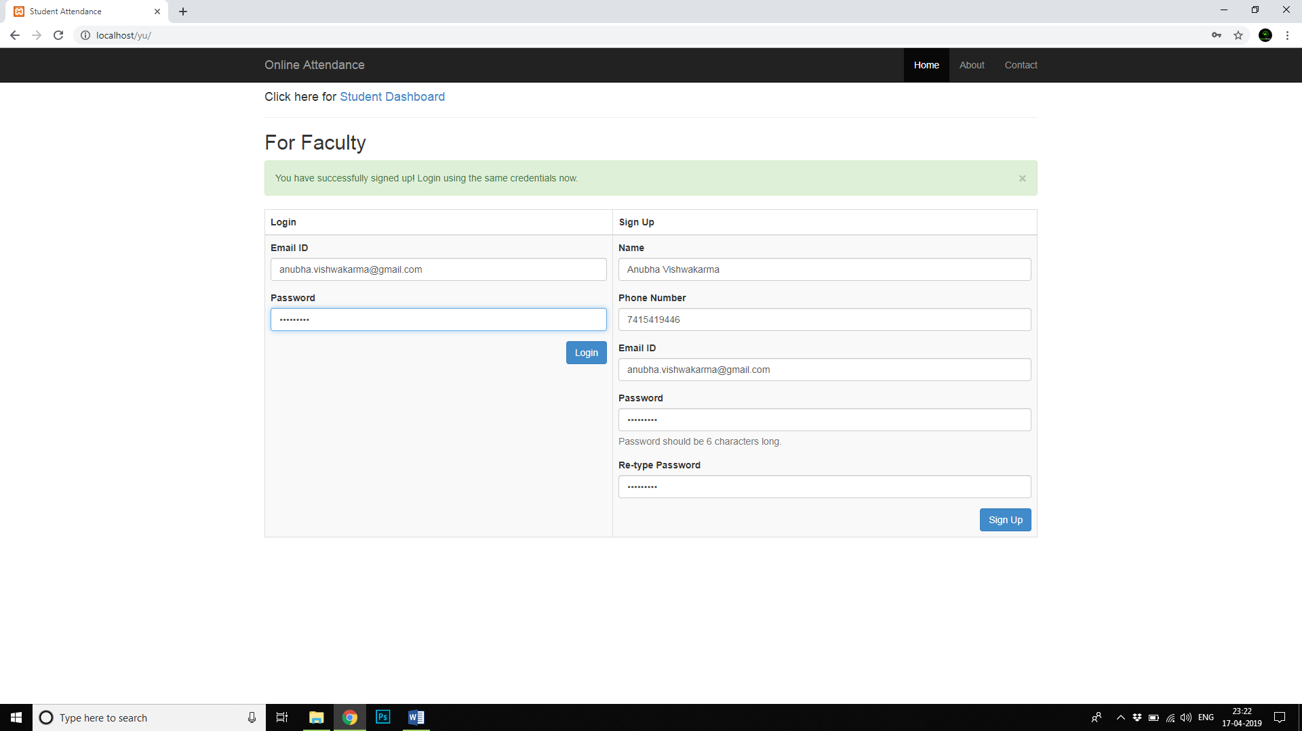

Fig No 3: After finishing the sign up process sign in through the browser.

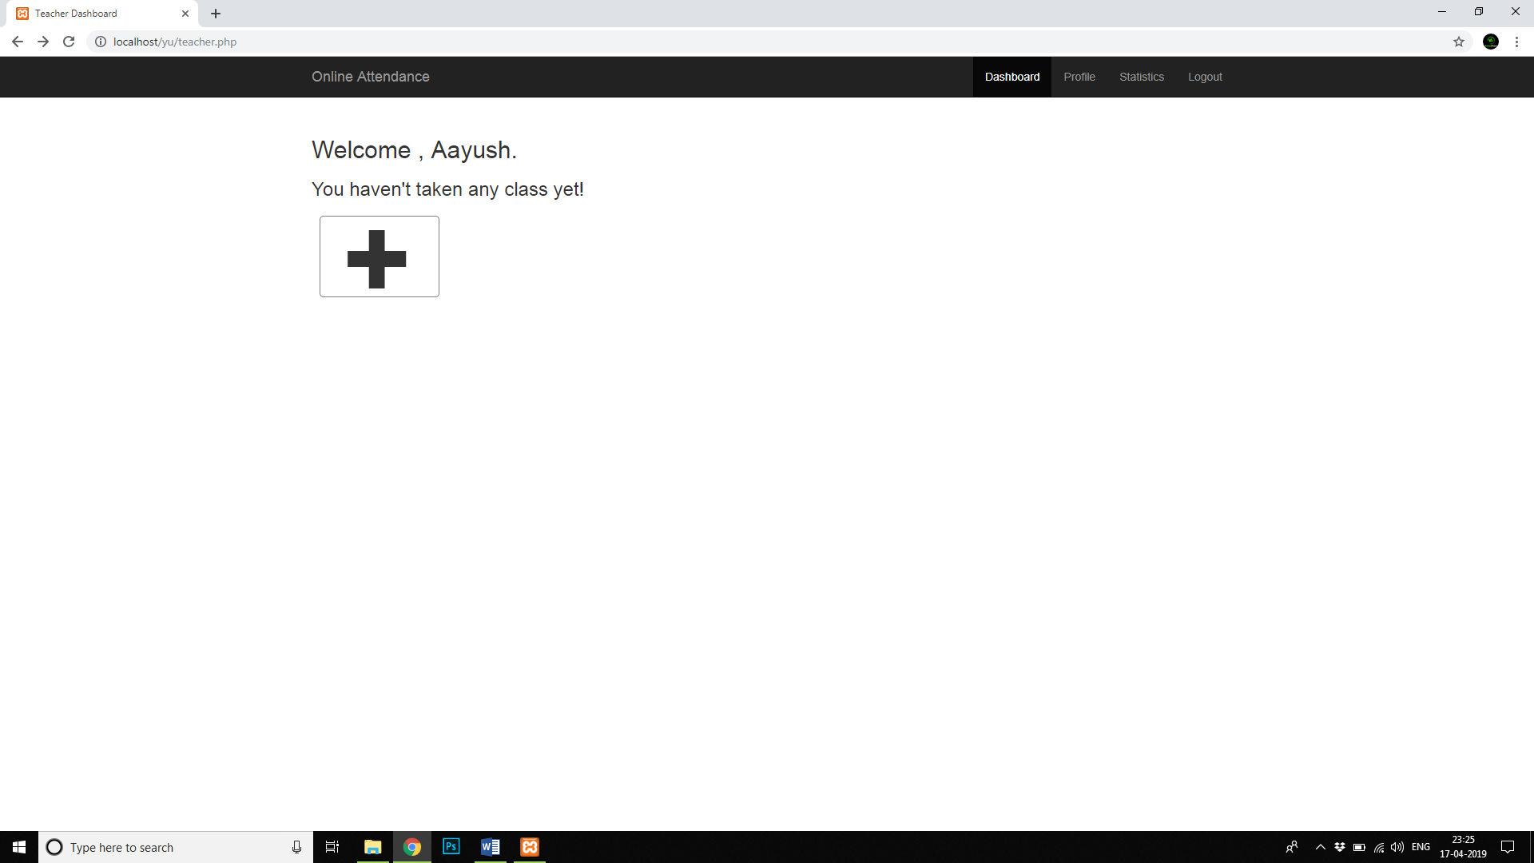

Fig No 4 : Faculty profile will appear on the screen.Click on add button to add classes on the profile.

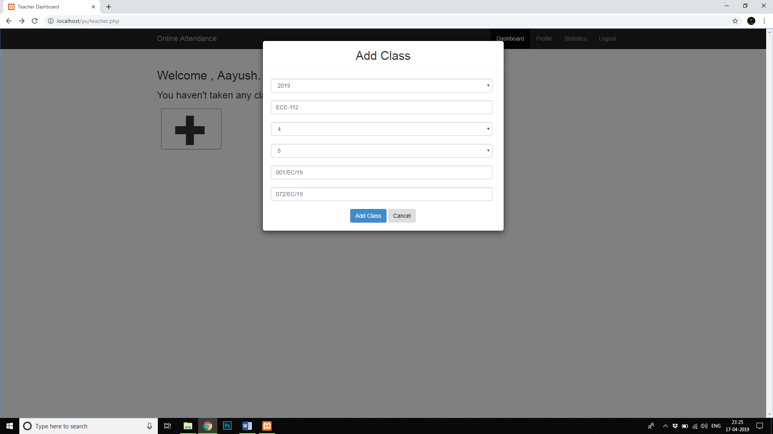

Fig No 5 : Fill in the essential details for each class that is to be taken.

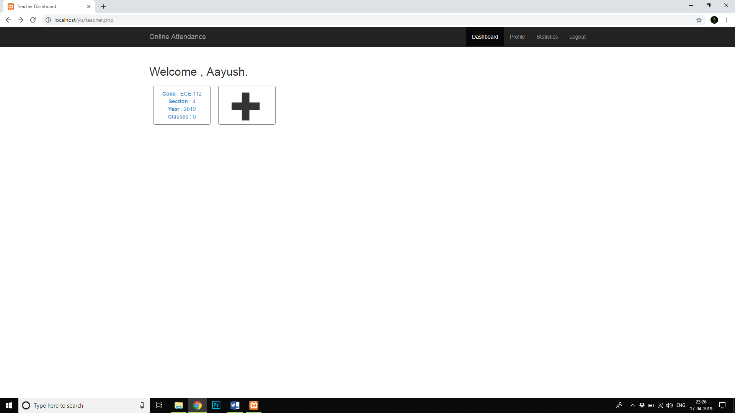

Fig No 6 : The classes will show on the faculty dashboard.Add as many classes as per the requirement

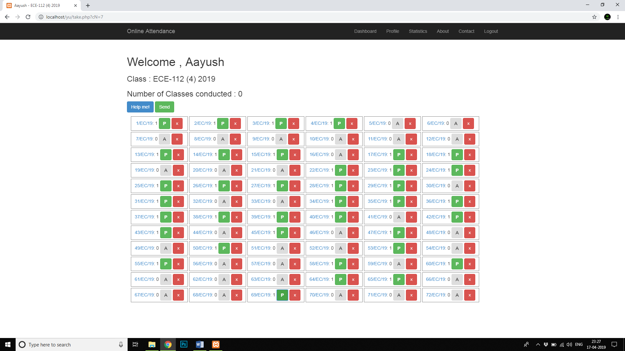

Fig No 7 : Open the tab and mark the attendance for each student. Each time you open the sheet for another class is opened to be updated.

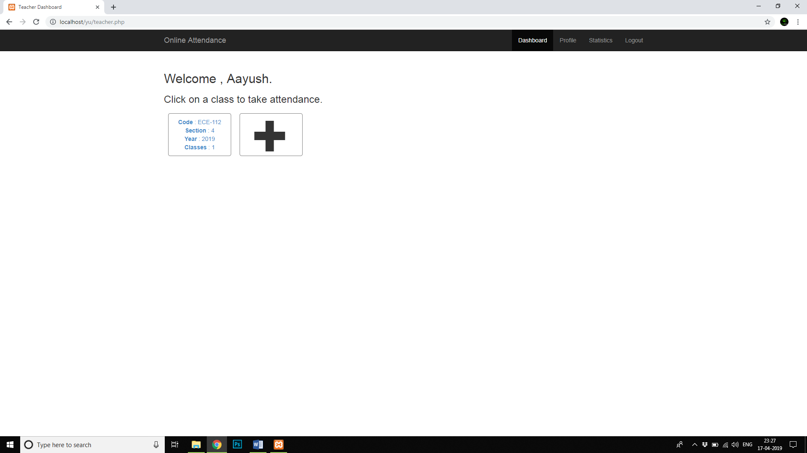

Fig No 8 : After marking the attendance and clicking on send the page is redirected to the Faculty Dash board.

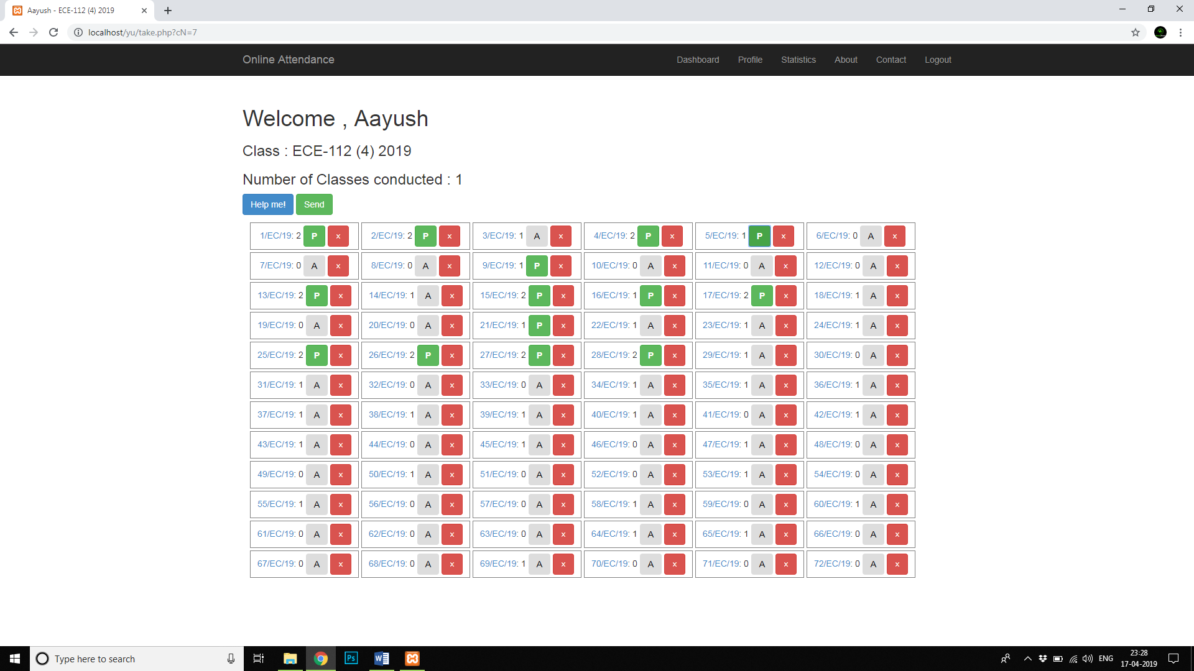

Fig No 9 : Attendance for the next day can be marked.

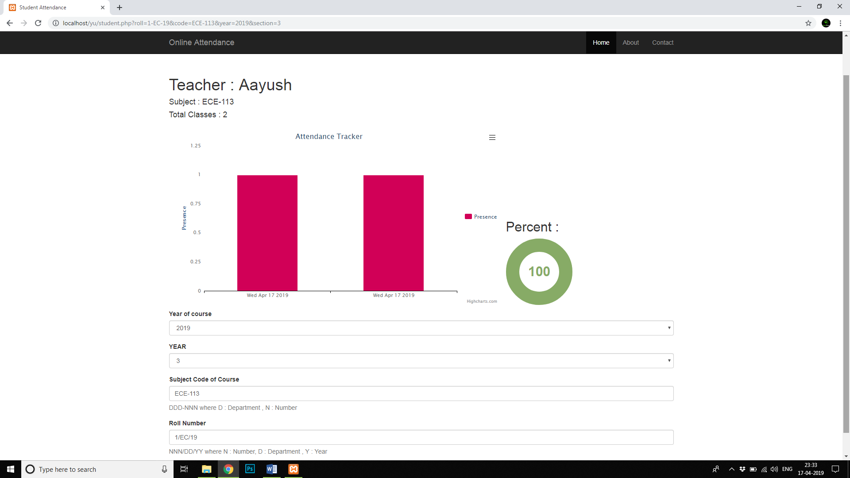

Fig No 10 : To check the attendance of a particular student click on the student roll no.The page will be redirected to a graph plot of the student profile with their attendance percentage.

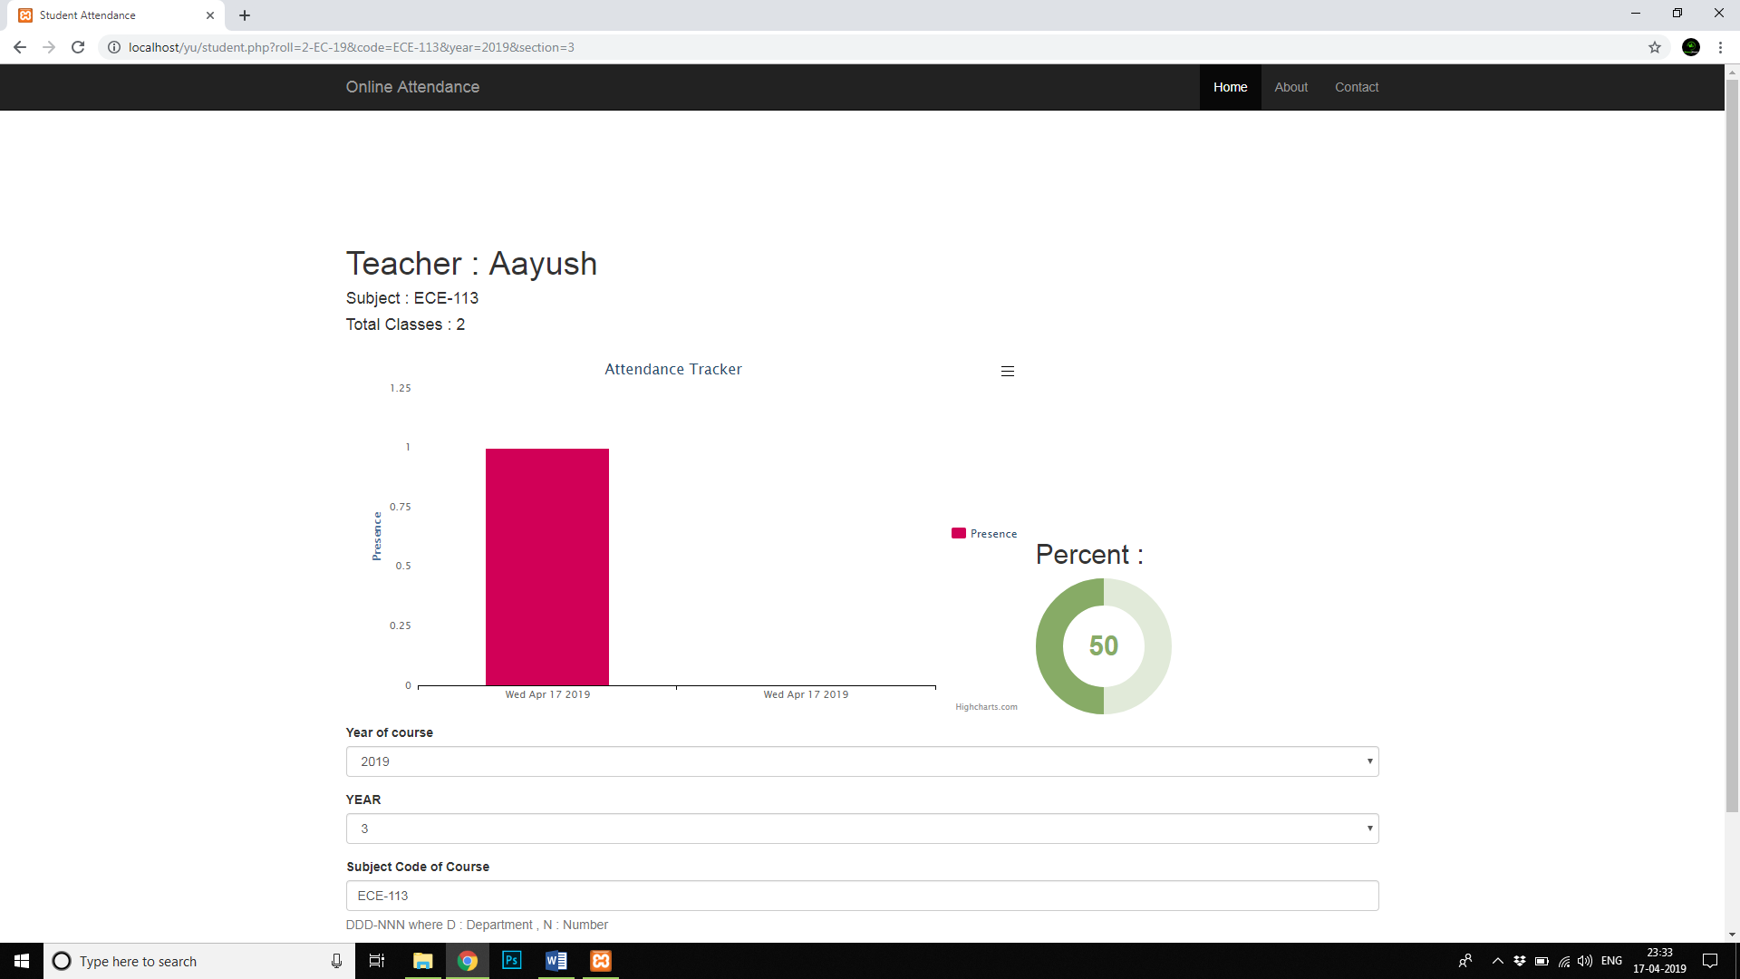

Fig No 11 : To check the attendance of a particular student click on the student roll no.The page will be redirected to a graph plot of the student profile with their attendance percentage.

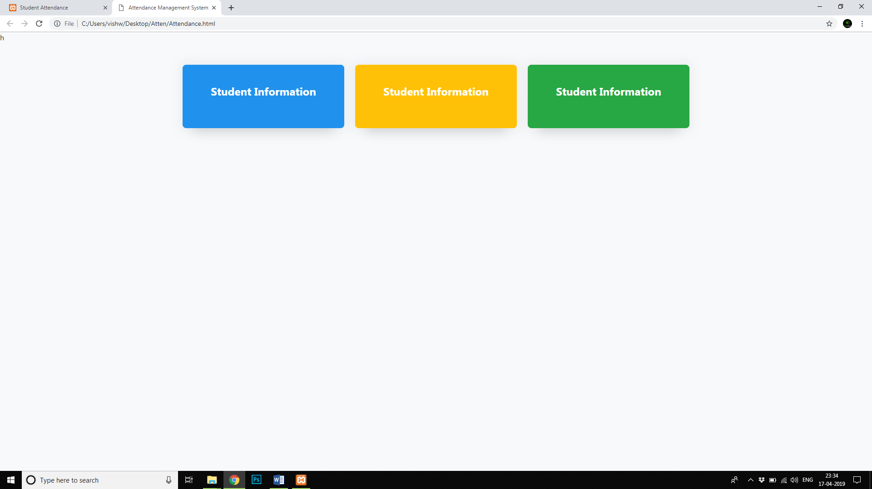

Fig No 12 : Open file:///C:/Users/vishw/Desktop/Atten/Attendance.html on your Browser window. This is the student attendance window.

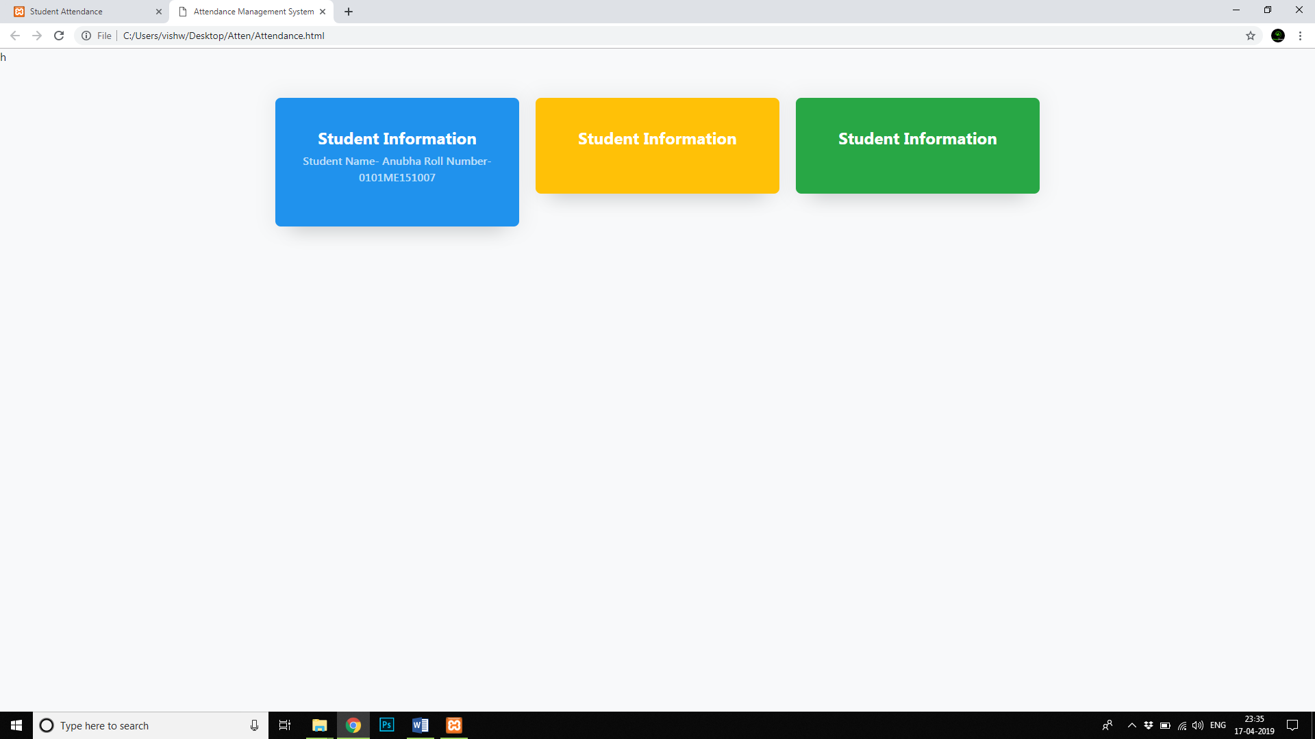

Fig No 13 : If we would place the RFID tag on top of the device ,the name of the student along with the details will appear on the window with the buzzer sound which indicates that the user is authenticated.

Both the interfaces can be merged with the help of Javascrip programs for a fully automated Attendance system.